2014-CZ-01-EN Price of a gift
0 ---- | I: hard | II: easy | III: ---- | IV: ----

Answer Type: Multiple Choice Graphics are: self made and colorblind proof

Body
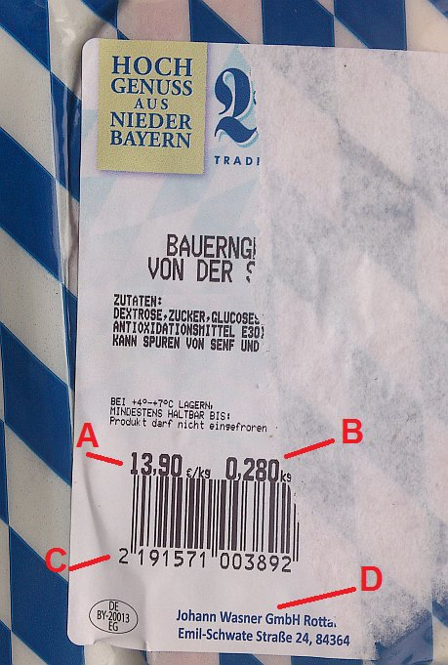
Stefan visited his friend Tom. He brought a piece of bavarian cheese as a gift to him. In order that Tom could not read the price he tore off part of the label (see photo). But Tom was able to read the price even so.

Question

From which information on the remaining part of the label is it possible to tell the price of the gift?

Answer

A) from information A
B) from information A and B
C) from information C
D) from information C and D

Explanation

The information A is a price of 1 kg of cheese. It is not the price of this piece of cheese.
The information B is a weight of this piece of cheese.
The information C is a product code. According to this code you cannot find out the price if you do not know which shop and which date this product was sold.
The information D is address and name of producer. It is impossible to determine the price at which the dealer sold this cheese.
The price of this product is possible to determine from the weight of the product and the price of 1 kg.

It's informatics

The task looks as math, but not. Who want to answer this task corectly must be able to choose from a variety of information it needs. He must understand the meaning of these numbers, codes and units and must understand information and situations in which they are used. This task is about comprehension of information.
Storage, stock records, inventory replenishment and logistics are nowadays done using computer systems. Barcodes, QR codes, PIN codes, etc. facilitate business transactions.

Keywords

Information comprehension, product code, product storage

Websites

Internal Use

Wording

Some information on the label – numbers, measurement units, codes, addresses on the photo of a part of the label

Comments

The photo of the label can be scaled down or cut out a detail for better reading.

Rephrased question after pre-review.

Files

All additional files for this task (graphics, scripts, etc.)
2014-CZ-01-EN Price of a gift.odt (this file)
2014-CZ-01-label.jpg (photo of the label)
2014-CZ-01-label-without-description.jpg (clear bigger photo without added graphics)

Authorship

Jiří Vaníček, vanicek@pf.jcu.cz, Czechia

License

Copyright © Bebras – International Contest on Informatics and Computer Fluency.
This work is licensed under a Creative Commons Attribution-ShareAlike 3.0 Unported License. Visit: http://creativecommons.org/licenses/by-sa/3.0/

